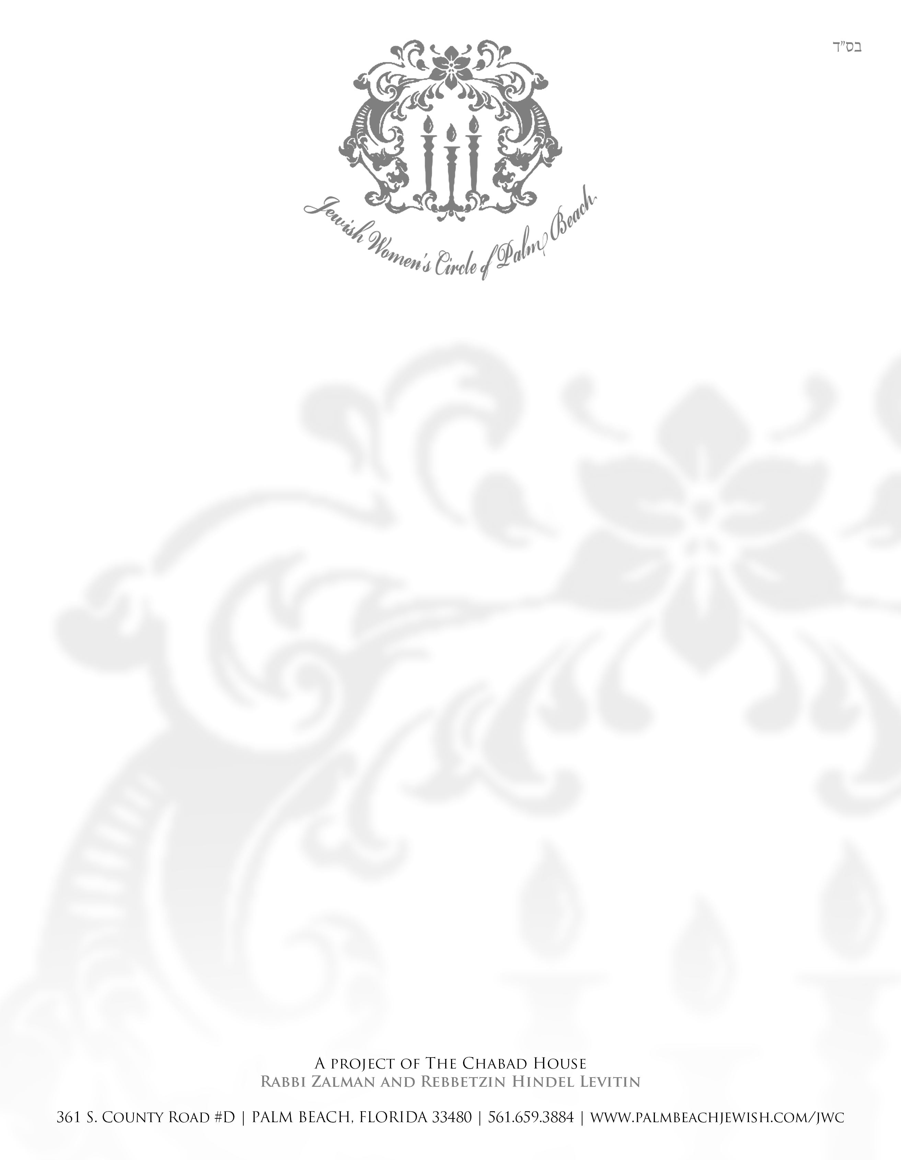Tuesday, February 18, 2014
Dear Frannie,
Thank you for a wonderful, inspiring evening! Your personal story is what made your words so effective. Additionally, the slides added a really great dimension to the evening. Nothing like seeing a point made - I am extremely visual myself.
I particularly loved what you said:
A: You mentioned that the slogan "fake it till you make it" has a big downside in that then we keep coming upon walls because of the faking and so we can never really make it. And that the REAL way to "make it" is to be authentic, not fake it or the faking catches up with you.
And B: I can totally feel the jaw-hurting smiles of the faking happy people you so hilariously portrayed with your tasteful humor. The general belief is that when someone smiles at you, good manners dictate that you should smile back. But, the people who are always smiling that hardened, forced smile, even when misery is evident in their eyes, let's just say I don't buy it. (Not to be confused with forcing ourselves to brush off and pick ourselves up even when G-d hands us challenges. I think you were talking about suppressing truths and difficulties to the point that it cripples us. It’s the “pretend game” that you pointed out is so unhealthy.)
Thriving not just surviving our lives - the title of your speech is truly what we all deserve and should aim for to serve G-d properly and with joy. Thank you for shining light for us all. You made the subject matter relatable to everyone. Your personal story as the whistleblower of your childhood family secrets is an overwhelmingly power capper to your lecture and gives you further credibility as an expert of this subject matter. As you saw, you created quite a stir with our Torah Institute of Palm Beach Island audience at The Chesterfield Hotel. People would have stayed even longer than the Question and Answer period which you had already generously extended.
You are incredible Frannie and are a pleasure to work with.
Respectfully,
Hindel Levitin

